**Sprint 3 Plan**

**UCSC Academic Planner, May 9th 2023**

**Goal**

* Get finalized frontend version working, with ability to show list of required courses for major, GE requirements, credits taken per quarter, and be able to generate a schedule for almost all majors.

**User Stories**

* 3.1 I am someone interested in UCSC and want to see a list of required courses for majors. [6] (Not completely finished from last time)

# Set up json/database

* + Finish adding all departments and majors from webpage
  + Integrate frontend/backend
  + Add frontend components telling you list of required courses
* 3.2 I am a UCSC student and I want to see if I fulfill all GE/major requirements to declare[5] (Unfinished from last time)
  + Add GE requirements to planner
  + Add frontend component to show GE/major requirements
* 3.3 I am a UCSC student and I want to see if I can graduate[5]
  + Add graduation requirements to planner
  + Add frontend component to show graduation requirements
* 3.4 I have a schedule that I made already, but want to make changes/possibly add classes [3]
  + Add ability to change classes and show what requirements will be changed/swapped because of the change

**Team Roles**

Betros Abraha (Product Owner)

Jin Lee

Brandan Fong

Sean Carlyle (Scrum Master)

Michelle Hernandez

**Task Assignment**

Betros Abraha: User story 3.1

Jin Lee: User story 3.4

Brandan Fong: User story 3.3

Sean Carlyle: User story 3.1

Michelle Hernandez: User story 3.2

**Planned Burnup Chart**

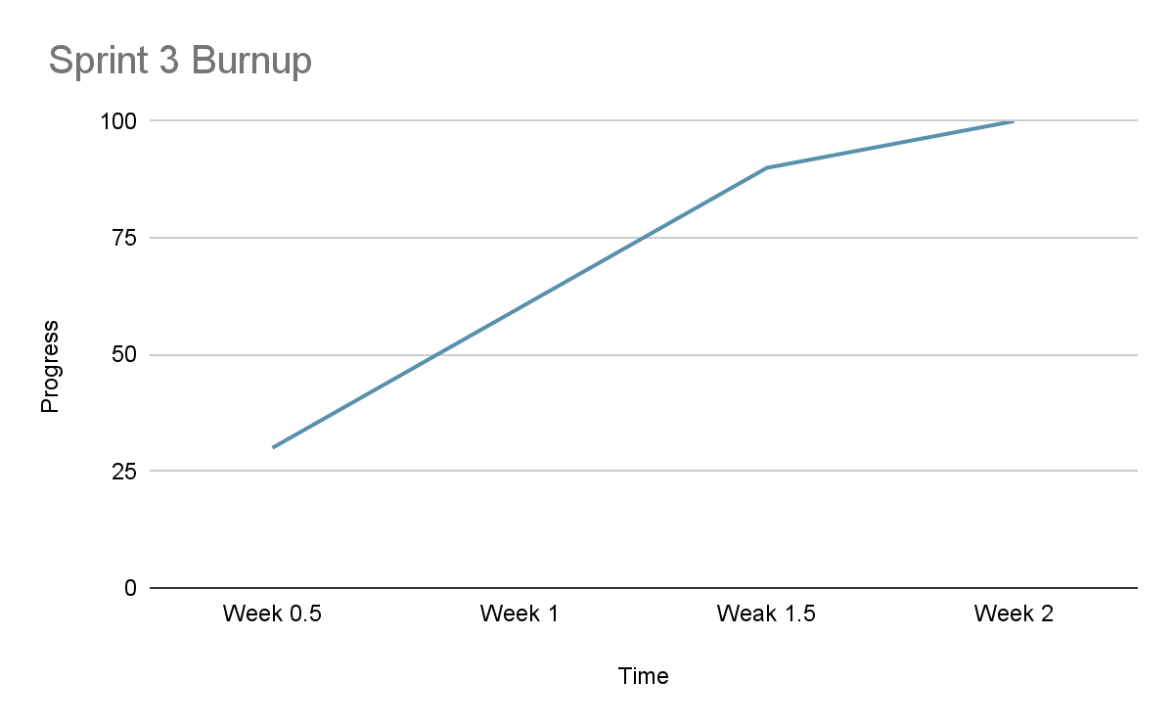

**Initial Scrum Board**

| **User stories** | **Tasks not started** | **Tasks in progress** | **Tasks completed** |
| --- | --- | --- | --- |
| * 3.1 I am someone interested in UCSC and want to see a list of required courses for majors. [6] (Not completely finished from last time) * 3.2 I am a UCSC student and I want to see if I fulfill all GE/major requirements to declare[5] (Unfinished from last time) * 3.3 I am a UCSC student and I want to see if I can graduate[5] * 3.4 I have a schedule that I made already, but want to make changes/possibly add classes [3] | * Add GE requirements to planner * Add frontend component to show GE/major requirements * Add graduation requirements to planner * Add frontend component to show graduation requirements * Add ability to change classes and show what requirements will be changed/swapped because of the change | Set up database  * Finish adding all departments and majors from webpage * Integrate frontend/backend * Add frontend components telling you list of required courses |  |

**Scrum Times**

Meeting MF 9:05am

TA meeting: W 4:45pm